**PROJECT DESIGN PHASE I**

**PROBLEM FIT SOLUTION**

|  |  |
| --- | --- |
| Date | 16 October 2022 |
| Team ID | PNT2022TMID12805 |
| Project Name | Project - Personal Assistance For Seniors Who Are Self-Reliant |
| Maximum Marks | 4 Marks |

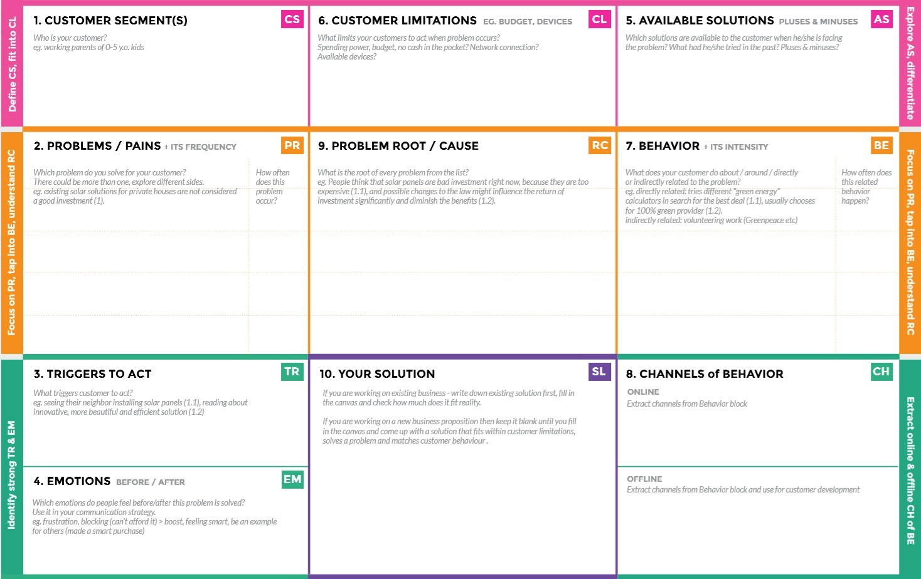

The caretaker needs to update the information

about the patient’s medication to the system and

check it regularly.

Medicine remainder system notifies when its time to take the medicine. It ensures to take correct medicine at correct time.

It helps the elderly people by acting as a helping hand to them.

Remainder to take medicines is very effective.

This system is very easy to handle as it has less complexity.

When they have financial constraints.

**Before:** The elders feel loneliness, stress and health gets affected due to forgetfulness.

**After:** This increases their confidence to live by reminding their medicines and their health recovers fast.

In offline newspaper advertisements can be done and we can promote with the help of entrepreneurs or influencers.

Promotion can be done through social media and online apps.

Our solution is to develop an application that reminds the elders their medicine at correct time. IoT device, web application, CloudantDB and text to speech are used where the medicine name and timing data are to be stored in CloudantDB. When its time to take medicine the web application notifies the IoT device through IBM IoT platform. Then the device receives the medicine name at the time and notifies the user using voice commands.

When they are left alone When all the family members are working or and by seeing other people using medicine remainder system, they also want to go for medicine remainder system.

Aging leads elderly people to forget what medicines to take at what time. This causes health issues.

Another cause is when there is no one to take care of them.

Elderly people simply forget to take their medicines at correct time. Nearly 40% of elderly patients do not know the purpose of medicines.

Sometimes they do not take medicines as they feel good and others stop taking them when they don’

Elderly people who are left alone by their children and when there is no one to take care of them and those who needs external support to take care of them for their medicines at correct time.